# Report for Brennan Wojick (2024-10-01 to 2024-10-31)

Average Bat Speed: 56.10

Average Rotational Acceleration: 6.76

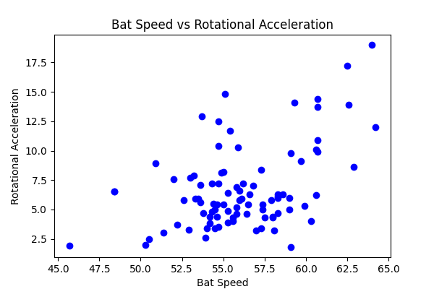

## Comments

Add comments here...